# **Template – Meal Plan Contract**

The template named “Template – Meal Plan Contract” is applicable to CampusNexus Student.

## Purpose and Outcome

This template provides a form sequence and supporting workflow for a meal plan contract to be completed by students online.

The sequence requires the following:

* A complete **Student record** must exist in the CampusNexus Student database.
* The student must have a **Portal login** to log into this authenticated sequence.
* CampusNexus Student must be configured as follows:
  + Student Services > **Service Categories**: The Meal Plan Service Category must be available. This is usually a preconfigured system category.
  + Student Services > **Service Billing Methods** must be configured for each meal plan.
  + Student Services > **Billing Services** must be configured for each meal plan to charge the student for the selected meal plan.
  + Contact Manager > **Documents** must include a Meal Plan Contract document type.

Forms Builder Settings must support must be configured for **DocuSign**. The template includes the steps required to collect a DocuSign signature from the student.

Upon completion of the sequence:

* A PDF file of the signed Meal Plan Contract is created and added to the student’s documents in Contact Manager.
* A Billable Services record is added for the student.
* A pending charge is added to the student’s Ledger Card.

The workflow looks up the student, enrollment, and term, creates the Student Services record, updates the student’s account, handles the DocuSign process, and sends the signed contract to the CampusNexus Student database

## Prerequisites

The template was built with Forms Builder using the applications listed below. The template is forward compatible with later versions of the listed applications.

|  |  |
| --- | --- |
| **Application** | **Minimum Version** |
| Forms Builder Designer and Renderer | 3.6 |
| Web Client for CampusNexus Student | 20.0 |
| Workflow Composer | 2.8 |
| Packages installed from Package Manager in Workflow Composer | Activities and Contracts (V1) 20.0.0  Activities and Contracts (V2) 20.0.0  Forms Builder Contracts 3.6 |
| Workflow Tracking Database | N/A |
| Staff STS 2.0 | 2.1 |

## Configuration

The web.config file in the CMCFormsRenderer_V3 folder must contain the following:

* SMTP settings to enable confirmation emails to be sent
* Database connection details to enable the workflow to query the database.

## Step 1: Download and Import the Template

1. Download the template file to your environment (local drive or network location).
2. Log into **Forms Builder Designer**.
3. Click the **Export/Import** tile.
4. Select the **Import** tab.
5. Click **Select exported file** and navigate to the downloaded template file.
6. Click **Import**.

* [Export/Import](https://help.campusmanagement.com/FB/3.x/Content/ExportImport.htm)

The following forms will be imported::

* Meal Plan Contract
* Default-Frame
* Meal Plan Contract Confirmation

## Step 2: In Form Designer…

1. From the **Forms** slide out, select the **Meal Plan Contract** form.
2. Customize the form for your environment. Modify properties on fields/components to make them required, etc., or add/remove fields on form.

Make sure you edit the text in the Labels and HTML controls as applicable for your institution.

* [Fields](https://help.campusmanagement.com/FB/3.x/Content/Fields.htm) and [Components](https://help.campusmanagement.com/FB/3.x/Content/Components.htm)

1. **Save** the form.
2. Repeat steps 1-3 for the Meal Plan Contract Confirmation form.

## Step 3: In Sequence Designer…

1. Locate the **Meal Plan Contract** sequence in the Sequences pane.
2. Click **Save As** to create a copy of the sequence/workflow and customize the copy for your use. This way you can always refer to the original sequence/workflow you downloaded.
3. Optional - Add a custom style (theme) associated with your campus.

* [Themes](https://help.campusmanagement.com/FB/3.x/Content/Themes.htm)

1. Select your saved sequence in the Sequences pane.
2. In the Properties Pane, select the **End State Form** named “Meal Plan Contract Confirmation”.
3. **Save** the sequence**.**

## Step 4: In Workflow Composer…

1. Open the workflow for your **Meal Plan Contract** sequence.

* [Opening Workflows for Sequences](https://help.campusmanagement.com/FB/3.x/Content/HostedEnv.htm)

1. Double-click the **Next** transition and expand the “Create Service and Charge” sequence.
2. Locate the **Assign Term ID** activity above the “Get Amount for Billing” activity.

The value “studentServiceTypeEntity.TermId” is hard-coded as 1269. Replace this value with the term ID appropriate for your environment or use a lookup/query activity to retrieve the value you need.

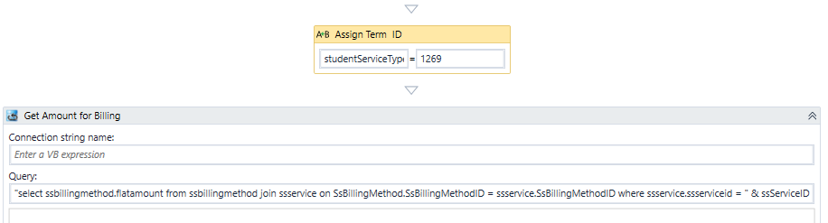

1. Locate the **LookupReferenceItem** activity in the “Post Meal Charge” sequence.

Select the Transaction Code for the meal plan charge as appropriate for your environment.

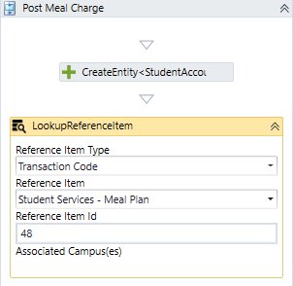

1. Scroll down to the **Assign Term ID** activity above the “Save Entity” activity.

The value “Fee.TermId” is hard-coded as 1269. Replace this value with the term ID appropriate for your environment or use a lookup/query activity to retrieve the value you need.

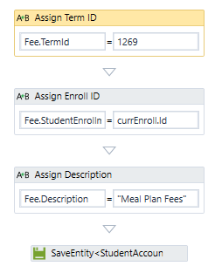

1. Locate the **CreateDocument** activity in the “Submit” transition before the End state form.

Select a **Document Type** value that is appropriate for your environment.

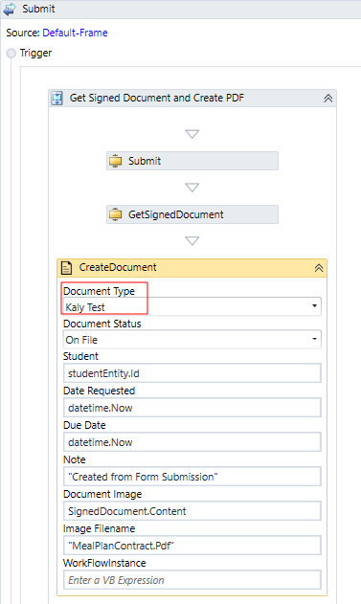

## Step 5: In Forms Renderer…

Select your sequence and try it out!

* [Sequence List](https://help.campusmanagement.com/FB/3.x/Content/SequenceList.htm)

1. Find your **Meal Plan Contract** sequenceand copy the **URL** to the clipboard.
2. Paste the URL into a browser and complete the form sequence.
3. Verify that a confirmation message is sent to the email address provided in the form
4. In CampusNexus Student, verify that a pending charge for the meal plan is added to the student ledger and that the signed document is added to the student’s document list.

## Step 6: Lastly…

Once your updated sequence has been tested successfully, it is recommended that you disable the workflow for the original Template version.

1. In Workflow Composer, in the Server section of the ribbon, click **Open**.
2. Find the workflow named **Meal Plan Contract**..
3. Clear the **Enabled** check box and click **Save**.